

Plot No.2, Sector 17-A, Yamuna Expressway,

Greater Noida, Gautam Budh Nagar, U.P., India

***School of Computer Science And***

***Engineering***



**Lab Report**

***B. Tech- II Sem***

**2023-24**

***Engineering Mathematics-II(Lab)***

**(C1UC222B)**

**Submitted by: Submitted to:**

Name: Gaurav. Dr. Vishal Singh sir

Section: 30(P1)

Admission number:23SCSE1180306

**Index**

**Experiment - 01**

**\*\*Write a sci lab code for the following problems: \*\***

**1.(i) Create a row vector with 3 elements.**

**Code:-** A=[1 2 3]

disp("Row vector with 3 elements=" ,A)

**Output:-**

"Row vector with 3 elements="

1. 2. 3.

**(ii) Create a column vector with 4 elements.**

**Code:-** A=[1;2;3;4]

disp("Column vector with 4 elements=",A,A)

**Output**:-

"Column vector with 4 elements="

1.

2.

3.

4**.**

**2. *By taking the first term a=1 and the last term b=10 create a vector :***

***(i) by taking the spacing between two consecutive terms d=2.***

**Code:-** A=[0:2:10]

disp(A)

**Output**:- 0. 2. 4. 6. 8. 10.

***(ii) by taking the number of terms n= 12***

**Code:-** A=linspace(0,10,12)

disp(A)

**Output**:-

0. 0.9090909 1.8181818 2.7272727 3.6363636 4.5454545 5.4545455 6.3636364 7.2727273 8.1818182 9.0909091 10.

**3. Create two-row vectors a and b such that the following operations are defined and hence find:**

***(i) 2a-3b,***

**Code**:- clc

clear

A A=[1 2 3]

disp("A=",A)

B=[4 5 6]

disp("B=",B)

C C=(2*A)-(3*B)

disp("2*A-3*B=",C)

**Output**:- "A="

1. 2. 3.

"B="

4. 5. 6.

"2*A-3*B="

-10. -11. -12.

***(ii)2(transpose a)-3(transpose b).***

**Code** :- clc

clear

A=[1 2 3]

disp("A=",A)

B=[4 5 6]

disp("B=",B)

C=(2*A’)-(3*B’)

disp("Answer=",C)

**Output**:-

"A="

1. 2. 3.

"B="

4. 5. 6.

"Answer="

-10.

-11.

-12.

***4. Find the angle between the following pair of vectors***

**(i) (0,0),(1,1)**

**Code** :- clc

clear

A=[0 0]

disp("A=",A)

disp("Norm(A)=",norm(A))

B=[1 1]

disp("B=",B)

disp("Norm(B)=",norm(B))

C=acosd(A*B’/(norm(A)*norm(B)))

disp("Angle between the both vector=",C)

**Output**:- "A="

0. 0.

"Norm(A)="

0.

"B="

1. 1.

"Norm(B)="

1.4142136

"Angle between the both vector="

Nan

**(ii) (1,2), (0,1)**

**Code** :- clc

clear

A=[1 2]

disp("A=",A)

disp("Norm(A)=",norm(A))

B=[0 1]

disp("B=",B)

disp("Norm(B)=",norm(B))

C=acosd(A*B’/(norm(A)*norm(B)))

disp("Angle between the both vector=",C)

**Output**:-

"A="

1. 2.

"Norm(A)="

2.2360680

"B="

0. 1.

"Norm(B)="

1.

"Angle between the both vector="

26.56505

**(iii) (0,1,0), (1,2,1)**

**Code** :- clc

clear

A=[0 1 0]

disp("A=",A)

disp("Norm(A)=",norm(A))

B=[1 2 1]

disp("B=",B)

disp("Norm(B)=",norm(B))

C=acosd(A*B’/(norm(A)*norm(B)))

disp("Angle between the both vector=",C)

**Output**:-

"A="

0. 1. 0.

"Norm(A)="

1.

"B="

1. 2. 1.

"Norm(B)="

2.4494897

"Angle between the both vector="

35.264390

**(iv) (1,2,3), (2,3,4)**

**Code** :- clc

clear

A=[1 2 3]

disp("A=",A)

disp("Norm(A)=",norm(A))

B=[2 3 4]

disp("B=",B)

disp("Norm(B)=",norm(B))

C=acosd(A*B’/(norm(A)*norm(B)))

disp("Angle between the both vector=",C)

**Output**:-

"A="

1. 2. 3.

"Norm(A)="

3.7416574

"B="

2. 3. 4.

"Norm(B)="

5.3851648

"Angle between the both vector="

6.9824973

**5. Draw the arrows for the following vectors:**

**(i) (1,2) (ii) (2,5)**

**Code** :- clc

clear

clf

plot2d([0,0])

xarrows([0,1],[0,2],3,3);

**Output**:-

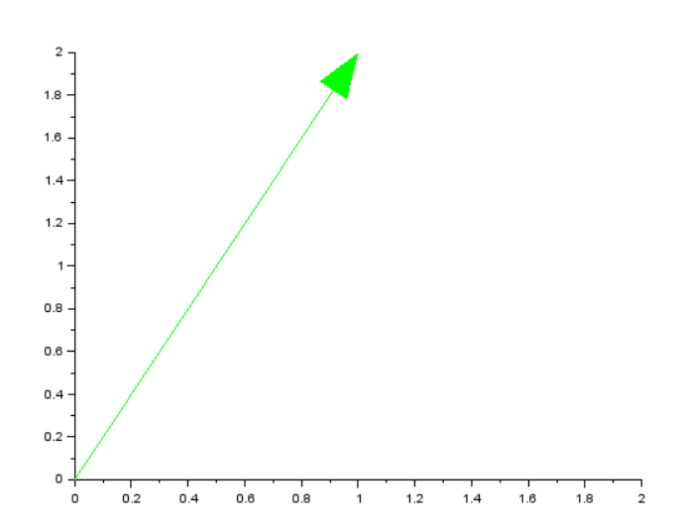

**(ii) (2,5)**

**Code** :- clc

clear

clf

plot2d([0,0])

xarrows([0,2],[0,5],4,4);

**Output**:-

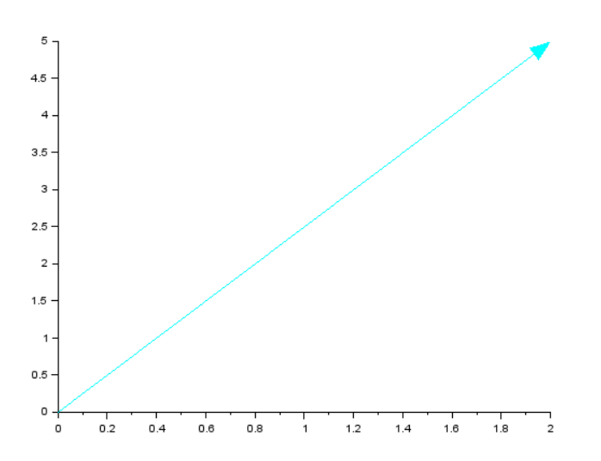

**(iii) (0,7)**

**Code** :- clc

clear

clf

plot2d([0,0])

xarrows([0,0],[0,7],2,5);

**Output**:-

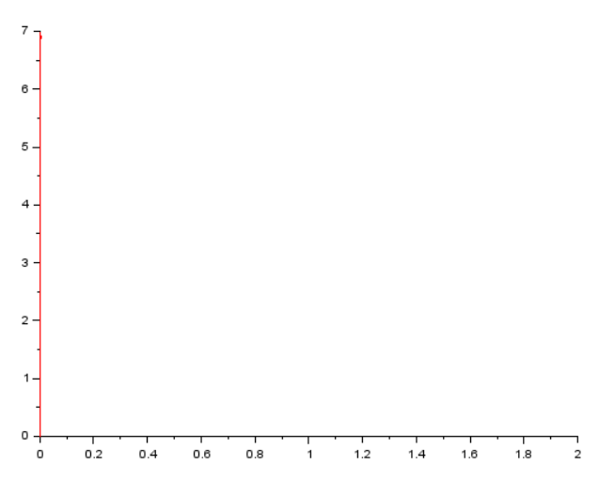

**(iv) (1,2,3)**

**Code** :- clc

clear

clf

plot3d([0,1,1],[0,1,1],[0,1,1],[0,1,2])

xarrows([0,1],[0,2],[0,3],2,5);

**Output**:-

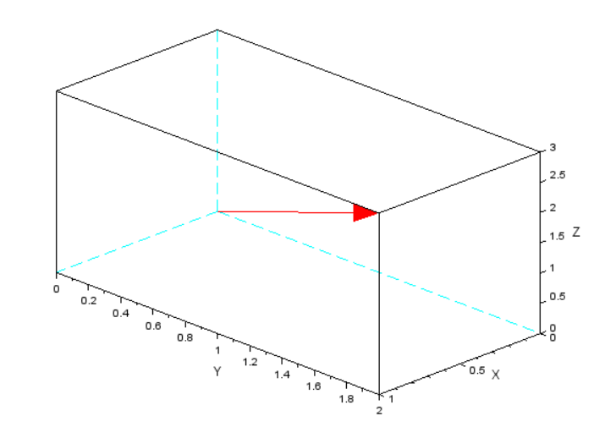

**(v) (-1,0,1)**

**Code** :- clc

clear

clf

plot3d([0,1,1],[0,1,1],[0,1,1],[0,1,2])

xarrows([0,-1],[0,0],[0,1],3,5);

**Output**:-

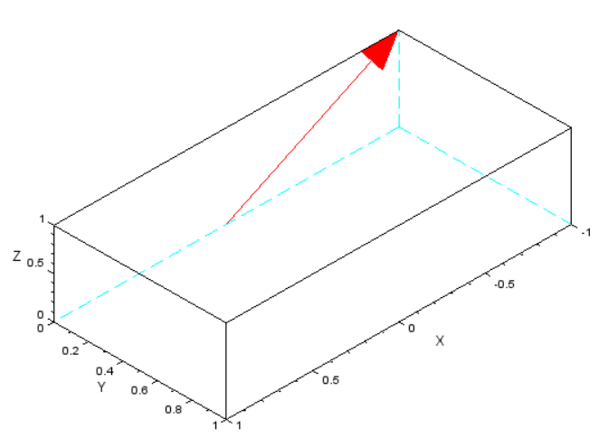

**(vi) (0,1,-1)**

**Code** :- clc

clear

clf

plot3d([0,1,1],[0,1,1],[0,1,1],[0,1,2])

xarrows([0,0],[0,1],[0,-1],2,7)

**Output**:-

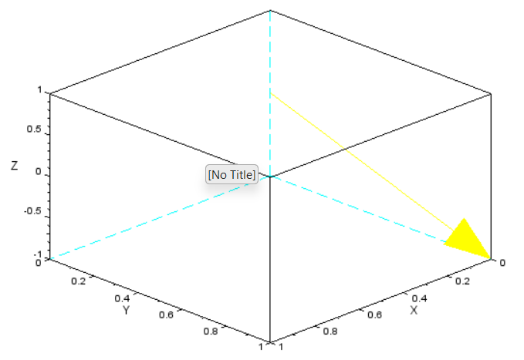

**6. Find the polar coordinates of the following vectors and draw their arrows:**

**(i) (1,2)**

**Code:-** clc

clear

clf

plot2d([0,0])

xarrows([0,1],[0,2],5,7)

theta= atand(2/1)

r=abs(sqrt(1**2+2**2))

disp("Theta=",theta)

disp("r=",r)

**Output**:-

"Theta="

63.434949

"r="

2.2360680

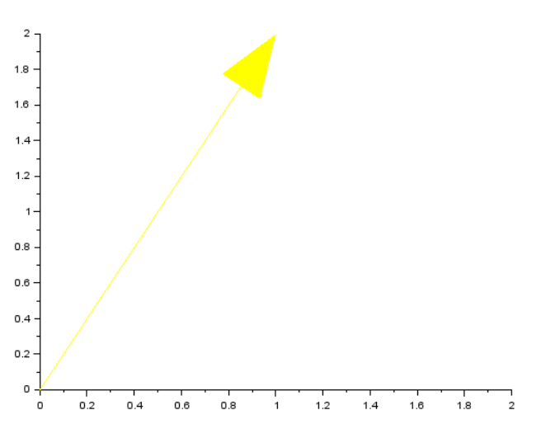

**(ii) (2,5)**

**Code:-** clc

clear

clf

plot2d([0,0])

xarrows([0,2],[0,5],3,2)

theta= atand(5/2)

r=abs(sqrt(2**2+5**2))

disp("Theta=",theta)

disp("r=",r)

**Output**:-

"Theta="

68.198591

"r="

5.3851648

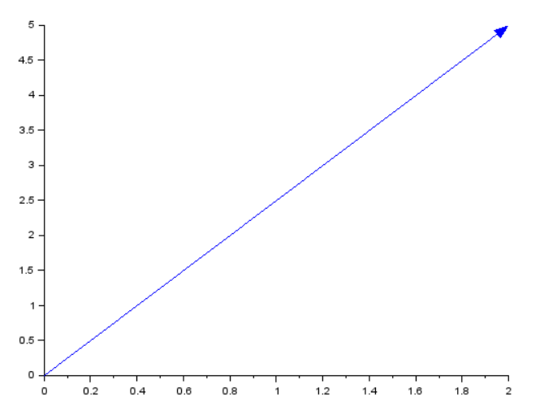**(iii) (0,7)**

**Code:-** clc

clear

clf

plot2d([0,0])

xarrows([0,0],[0,7],6,9)

theta= atand(7/0)

r=abs(sqrt(0**2+7**2))

disp("Theta=",theta)

disp("r=",r)

**Output**:-

"Theta="

90.

"r="

7.

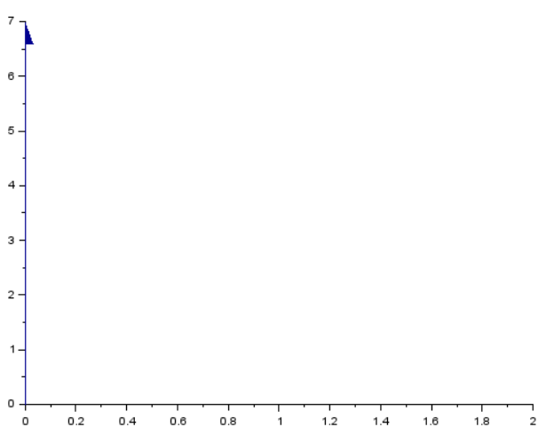

**(iv) (1,2,3)**

**Code:-** clc

clear

clf

plot3d([0,1,1],[0,1,1],[0,1,1],[0,1,2])

xarrows([0,1],[0,2],[0,3],4,5)

p phi=atand(2/1)

r=abs(sqrt(0**2+7**2+3**2))

theta=acosd(3/r)

disp("phi=",phi)

disp("r=",r)

disp("Theta=",theta)

**Output**:-

"phi="

66.801409

"r="

7.6157731

"Theta="

66.801409

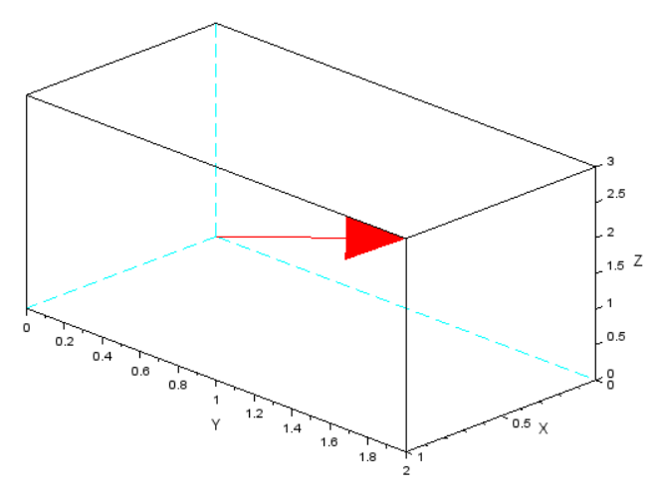

**(v) (-1,0,1)**

**Code:-** clc

clear

clf

plot3d([0,1,1],[0,1,1],[0,1,1],[0,1,2])

xarrows([0,-1],[0,0],[0,1],2,7)

p phi=atand(0/-1)

r=abs(sqrt(-1**2+0**2+1**2))

theta=acosd(1/r)

disp("phi=",phi)

disp("r=",r)

disp("Theta=",theta)

**Output**:-

